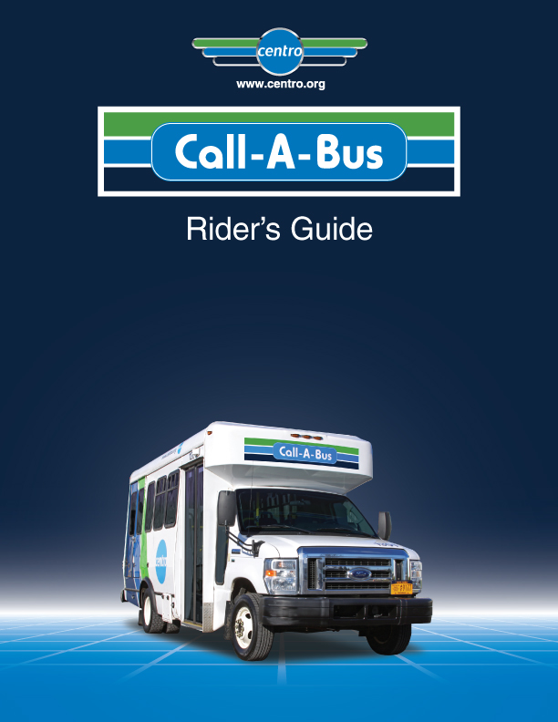

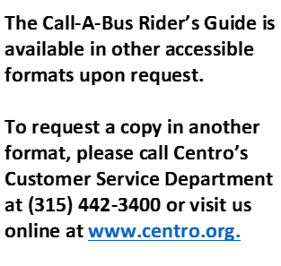
Table of Contents
Section 1: What is Call-A-Bus? ....................................................................................................................... 3
Section 2: Call-A-Bus Eligibility Categories............................................................................................................... 3
Section 3: Service Hours/Days ................................................................................................................................... 5
Section 4: Personal Care Attendants and Companions ........................................................................................... 7
Section 5: Call-A-Bus Service and Children 7
Section 6: Service Animals 7
Section 7: Requesting a Ride 8
Section 8: Negotiating Your Ride 9
Section 9: Confirming Your Ride 10
Section 10: What to Expect on Your Travel Day 11
Section 11: Accessibility Features 12
Section 12: Passenger Responsibilities 13
Section 13: Call-A-Bus Responsibilities to Our Passengers 14
Section 14: Respect the Ride 15
Section 15: Cancellations and Changes 16
Section 16: No-Shows and Late-Shows 16
Section 17: Comments, Compliments, and Complaints 17
Section 18: Persons with Disabilities Visiting our Community 18
Section 19: Appeal Policy 18
Section 20: Glossary of Terms 19
Section 21: Important Phone Numbers 21


Section 1: What is Call-A-Bus?

Call-A-Bus is a transportation service of the Central New York Regional Transportation Authority (Centro) for persons with a functional disability who are unable to use the Centro fixed route bus for some or all of their trips due to the effects of their disability. Call-A-Bus operates at the same times and in the same areas as the Centro Fixed Route bus, with very few exceptions. Call-A-Bus operates in full compliance with the Americans with Disabilities Act (ADA). Individuals are eligible as follows:
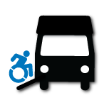
- Any person who is unable to board, ride, or exit a Centro Fixed Route bus without the assistance of another person as a result of a physical, visual, or mental disability.

- Any person with a functional disability who has a specific impairment-related condition that makes it impossible for them to travel to a Centro Fixed Route bus stop.
Section 2: Call-A-Bus Eligibility Categories

Once you have successfully applied for Call-A-Bus service, you will be assigned one of these eligibility categories. People who can use the Centro Fixed Route Bus under all circumstances are not eligible for Call-A-Bus. Please check the letter we sent to you, which explains your eligibility. Call-A-Bus eligibility must be re-certified after five years.
- CONDITIONAL ELIGIBILITY
Conditional Eligibility is based on your abilities and the trip you wish to take. You have the functional ability to use the Centro Fixed Route bus system for some, but not all of your trips. You can request Call-A-Bus service when there are situations making a Centro Fixed Route bus trip impossible (e.g., snow and ice are covering walkways, making it impossible for you to get to a Centro Fixed Route bus stop, or you must walk farther than you are able). Call-A-Bus staff will consider the conditions in which you are eligible on a trip-by-trip basis when you call to request a trip. Call-A-Bus customers are encouraged to check Centro Fixed Route Bus information before you call Call-A-Bus. Centro Bus information is available by calling your local Centro Office or visiting the website at www.centro.org.
Conditional Eligibility Example: Mary is able to walk 2 blocks to a Centro Fixed Route Bus stop to catch the bus, and she often uses the bus if her destination is near a bus stop. However, she has a monthly appointment at an office that is over 4 blocks from a bus stop. Mary has Conditional Eligibility for trip locations that are more than 2 blocks from a stop. She can receive a Call-A-Bus ride for those monthly trips and still use the Centro Fixed Route bus during the week.
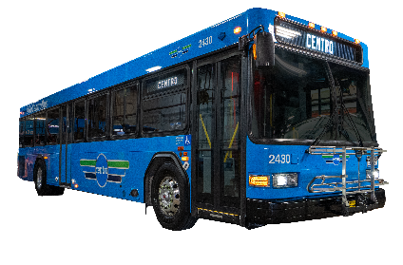
Using Centro’s Fixed Route Bus

There may be times when you can use the Centro Fixed Route Bus for your trip.
Why use the Centro Fixed Route Bus?
Centro Fixed Route Bus
- The Centro Transfer Hub is safe, covered, and staffed with information and safety personnel.
- The Centro Fixed Route Bus offers a reduced fare for people with disabilities.
- Using the Centro Fixed Route Bus does not require an advance reservation.
- The Centro Fixed Route Bus enables you to change trip plans on short notice.
- You can travel with a larger group of friends and family.
- The Centro Fixed Route Bus travels a specific and fixed route. Call-A-Bus is a ride-sharing service. The route is determined by demand, and others may be picked up and dropped off before you.
- Centro Fixed Route Bus routes serve suburban locations that only operate a few times in a day (typically only in the AM and in the PM when riders are going to work or coming home).
Fixed Route Buses have ramps or lifts enabling people with wheelchairs, scooters, and other mobility devices to board safely. Persons who cannot climb the bus stairs may request to use the lift or ramp.
The first seats on the bus, nearest to the driver, are designated for people with disabilities to make it easier to communicate with the driver and to board and alight more easily.
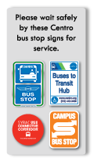
Centro Fixed Route Buses are equipped with "kneelers" that lower the bus by several inches, making the first step more accessible for those who have difficulty with stairs.
Major stops are announced along the way. If you want to get off the bus at a certain stop and are not sure where it is, let the driver know, and he/she will help you.
For Centro Fixed Route Bus Information, please call your local Centro office (see Section 21) or check our website for maps, timetables, and special services at www.centro.org.
If you have never ridden on a Centro Fixed Route Bus and would like to try, please call your local Centro office to arrange a Travel Training session with our staff.
Fixed Route
Stop Signs

FEEDER SERVICE
Call-A-Bus may use the regular Centro Fixed Route system to provide some parts of a customer’s trip. This will be based on your eligibility conditions.
Feeder Service Example: Mary would like to go to the New York State Fair. She is able to walk 2 blocks to a Centro Fixed Route bus stop to catch the bus. From home, the nearest bus stop is 4 blocks away. Call-A-Bus may pick Mary up at her home and take her to the nearest park and ride bus stop location, where she would catch the Centro Fixed Route bus to the New York State Fair. The bus stop location will drop her off within 2 blocks of her destination.
2. ELIGIBILITY IN ALL CASES
Due to your functional ability, you cannot use the Centro Fixed Route bus, or you can never get to a bus stop. You will be eligible for all trip requests made that fall within the times and areas in which Call-A-Bus service operates.
3. TEMPORARY ELIGIBILITY (conditional or in all cases)
You may have a short-term disability that prevents you from using the Centro Fixed Route bus or getting to and from a bus stop. You should also keep us informed if your condition changes in any way. If your temporary disability turns into a long-term disabling condition, we will ask you to recertify for Call-A-Bus.
Section 3: Service Hours and Days

Call-A-Bus is an origin-to-destination service. Origin-to-destination means the pick-up and drop-off locations are at the street curb. If you need assistance to the exterior door of a location, please let us know at the time you make your trip reservation so we can plan accordingly.

Call-A-Bus is a ride-sharing service. On most trips, more than one person is riding, and there may be several pick-ups and drop-offs before you reach your destination.
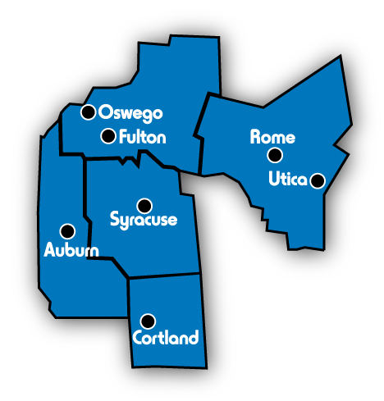
By Federal Law, Call-A-Bus cannot prioritize service by trip purpose, nor will it limit the number of trips to eligible individuals.
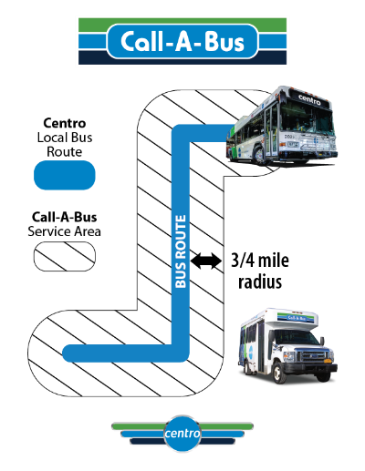
SERVICE AREA AND HOURS
To determine if your trip is eligible, check the Centro Fixed Route Bus schedules that serve the places you travel to and from.

Call-A-Bus service is available within ¾ miles of the Centro Fixed Route Bus routes. That means both the origin and destination of each trip must be within the corridor measuring ¾ mile on either side of the bus routes. If your residence is changing, it is recommended that you verify that your new address is still within the area Call-A-Bus is able to travel.
Call-A-Bus service is available during the hours when Centro Fixed Route Bus service is available (e.g., if the Centro Fixed Route Bus you would take operates between 6:00 AM and 6:00 PM, then your Call-A-Bus trip must be between 6:00 AM and 6:00 PM. If the matching Centro Fixed Route Bus service does not operate on Sundays, then there is no Call-A-Bus service available on Sunday).
Call-A-Bus service is not available on Centro Fixed Route Bus commuter routes, which only provide service during morning and afternoon rush hours with limited stops between an origin and destination.
PAYING YOUR FARE
Syracuse | $2.00
Commuter (Syracuse - Auburn/Fulton/Oswego) | $6.00
Auburn | $2.00
Oswego | $2.00
Utica | $2.00
Rome | $2.00
Commuter (Utica/Rome) | $6.00
Cortland | $2.00
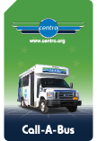
Call-A-Bus is a pay as you board service. Fares must be paid with either exact change, Call-A-Bus ride passes, or Credit Card (can only be set up in the MOVE app). Information on how to purchase passes can be obtained by calling Centro’s Customer Service Department or by visiting the Centro website. Drivers do not make change. Your Call-A-Bus Transportation Coordinator can tell you the exact fare for your trip at the time you make your trip request.
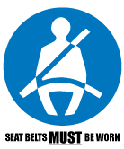
The use of safety belts is required for all passengers. Safety belts include lap belts and shoulder belts. Children under the age of 8 must be in a federally approved car or booster seat. National experience shows that safety belts prevent or reduce serious or fatal injuries by 50 percent. We, the employees and contractors of Centro, want to provide the safest ride possible.
Ride Pass
The requirement to use safety belts includes trips taken on Centro's Call-A-Bus vehicles and private companies working for the Call-A-Bus service.

Refusal to wear a safety belt will result in a suspension of service until such time that you agree to comply with the policy. Drivers will notify Dispatch if a passenger refuses to use a safety belt. Any seatbelt exemption granted must meet the requirements of the NYS DOT laws. Contact the Call-A-Bus office for further details.
Section 4: Personal Care Attendants and Companions
Customers should consider traveling with a Personal Care Attendant (PCA) when additional assistance is needed. A PCA must be picked up and dropped off at the same location as the customer. One PCA may ride at no charge.
You may travel with 1 companion in addition to your PCA. Companions must be picked up and dropped off at the same location as the customer. Companions (i.e., a friend, relative, or children 6 years of age or older), must pay the same fare as you for each trip. Additional companions (a second or third person) may be allowed on a space-available basis only. Eligible Call-A-Bus customers are provided service before accommodating extra companions. Due to the limited space available on Call-A-Bus vehicles, additional passengers need to be included in your trip request.
Section 5: Call-A-Bus Service and Children
Children with disabilities, ages 6 years and above, may be individually certified as Call-A-Bus eligible if they meet the ADA criteria. They may travel independently without an adult if they can demonstrate they would be able to use the Centro Fixed Route Bus if not for their disability. Call-A-Bus eligible children must pay the full Call-A-Bus fare appropriate to their trip. Centro is only responsible for passengers, including children, while they are on the vehicle.
All children under age 6 must be accompanied by a Call-A-Bus eligible adult and may ride for free.
Please tell us if you will be traveling with children at the time you make your trip reservation.
All children under 8 years of age must have an appropriate child safety restraint system (car seat) in accordance with New York State’s DOT Seat Belt Law. It is the customer’s responsibility to provide and properly secure the equipment and child.

Section 6: Service Animals
A service animal is an animal specifically trained to do work or perform tasks for the benefit of an individual with a disability. Your service animal is welcome on board. We do ask that you inform us at the time of your trip requests that you will be traveling with your service animal.
Service Animals

Customers are responsible for their service animal's grooming and behavior. A service animal is not allowed to occupy a seat but can sit in your lap if you choose. Larger animals should stay seated on the floor next to you and should not interact with other passengers except with their permission. You must have control of your service animal at all times, either by voice command or touch.
If you use the wheelchair lift and have a service animal, please be aware that your service animal cannot accompany you on the lift. You may guide and command the service animal to enter the vehicle using the stairs, and put the animal in a stay position while you board. As an option, you may also board the vehicle and call the service animal to enter the vehicle using the stairs.
A WORD ABOUT PETS
Call-A-Bus cannot transport pets unless they are in a carrier and you are able to carry and hold the carrier. This is for their safety.
Please keep in mind that not all people enjoy being around animals, and some have health conditions that are aggravated by exposure to fur, hair, dander, etc. If you plan to travel with a pet in a carrier, please inform us at the time of your trip request.
Section 7: Requesting a Ride
Trip requests can be made by calling your local Call-A-Bus office up to 14 days in advance, but at least one day in advance of your travel or through Centro’s MOVE app available in the app store.
Hours for requesting a ride in Onondaga County are from 8:00 AM to 5:00 PM, 7 days a week.
When calling to make your trip request, please have the following information ready:
1. My name is _________________________________.
2. My ID number is _____________________________.
3. My PICK-UP address is __________________________________________________.
4. I am GOING to _______________________________________________________________ (address).
5. This is a round-trip or one-way ride (select one).
6. I would like to reserve a ride on ______________________________ (day and date).
7. (Choose one)
a. I would like to be picked up at _______________ (time).
b. I need to arrive at my destination by ____________________ (time).
Additional information to be provided, if needed.
- I am traveling with a Service Animal, Companion, or Personal Care Attendant.
- I will have packages (limit 6 grocery bags). Could the driver help me get them to the door?
- I need an escort to or from the door to the vehicle.
At this point, you have a choice of calling back the day before your trip to confirm your arrangements, receive your pick-up times, and find out what type of vehicle will be picking you up. This information is also available on the MOVE app and alerts can be sent to notify you about your upcoming trip. If your trip is scheduled at the time of your request, we will only be able to give you an estimated pick-up time. If you call back the day before your travel day, we will be able to provide you with a more defined pick-up and drop-off time window.
Section 8: Negotiating Your Ride or “Live Scheduling”
Criteria established under the Americans with Disabilities Act allows Call-A-Bus to schedule your trip within a "window" of one hour before your requested time, to one hour after your requested time. Trips reserved two days or less prior to the date of travel may be scheduled within the one-hour window. This is referred to as “Live Scheduling.”
We strive to give you times that best match your request.
Live Scheduling Example:
You call on Thursday to reserve a trip for tomorrow, Friday. You request a one-way trip and need an arrival time of 3:00 PM. While you are on the phone, the Call-A-Bus Transportation Coordinator will try to schedule your ride within your requested arrival time. Unfortunately, there is no space available on a vehicle to get you to your destination by the 3:00 PM arrival time you have requested. The Call-A-Bus Transportation Coordinator will explain that you will need to “negotiate the ride” or “live schedule.” The Call-A-Bus Transportation Coordinator will offer you two choices: 1) an arrival time that may be as early as 2:00 PM (one hour before your requested arrival time) or 2) as late as 4:00 PM (one hour later than your requested arrival time). It is your choice whether you would like to accept the earlier arrival time or the later arrival time.
Call-A-Bus is a ride sharing service and these time frames allow us to schedule and provide all of our eligible customers with a ride. It may mean you arrive at your destination earlier or later than you originally requested. We recommend you check opening or closing times at your destination to avoid long waits outside a building that is closed and locked.

Call-A-Bus is unable to honor customer requests for specific drivers, seats, vehicles, or direct routes.
If you must be at a certain destination by a specific time, you are negotiating your drop off time. It is important for you to tell the Call-A-Bus Transportation Coordinator at the time you make your trip request. This is especially important if you have an appointment, are going to a job, or attending a special event. “I must be there by ____________________.”
On your return trip, be sure to give us the time you will be ready to board the vehicle.
For example, your work shift may end at 3:00 PM, but you need 10 to 15 minutes to clean up, get your coat on, and punch out. Remember, our vehicles will only wait 5 minutes beyond the scheduled pick-up time. So, in this example, you would ask to be picked up no earlier than 3:15 PM. "I will be ready to be picked up at ____________________.”
You may request either your pickup time or your drop off time for each trip, but not both (e.g., you cannot request to be picked up at 9:45 AM for an appointment at 10:00 AM - rather, you would ask to be dropped off at your appointment before 10:00 AM). Your pickup time will be dependent on the number of trip requests at that hour, the travel distances involved, and traffic patterns.
Section 9: Confirming Your Ride
Call-A-Bus recommends that you call/check the MOVE app the afternoon before your travel day to confirm your addresses, pick up times, and vehicle for the next day. While not required for service, the confirmation call assures that we have the correct information.
Please contact your local Call-A-Bus office to determine the times of day they process confirmation calls. Normally, trip schedules for the next day are ready by 3:00 PM the working day before.
Confirmation hours are as follows:
- Monday – Thursday: 3:00 PM – 6:00 PM (for trips on the following day).
- Friday: 3:00 PM – 6:00 PM (for trips on Saturday, Sunday, or Monday).
- Saturday & Sunday: 8:00 AM - 5:00 PM (for trips on the following day or for Monday).
- Holidays: 8:00 AM – 5:00 PM (for trips on the following day).
If you were unable to confirm your next day’s trip during the regular confirmation hours, you may confirm your trip on the day it is scheduled to occur. Hours for same day confirmation calls are from 5:30 AM to 6:00 PM, Monday through Friday and 8:00 AM to 5:00 PM, Saturday, Sunday, and Holidays.

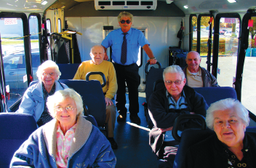
Section 10: What to Expect on Your Travel Day
Call-A-Bus is a ride sharing program. This means other customers will likely be picked up and/or dropped off during your trip. To accommodate all customers, we may or may not follow the most direct route between your origin and destination.
We try to keep your ride time as short as possible. We use the following maximum travel time standards:
- Trips up to five miles – allow up to one hour of travel time.
- Trips greater than 5 miles and up to 10 miles – allow up to 90 minutes of travel time.
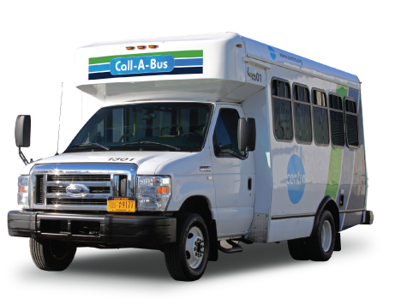
- Trips greater than 10 miles – allow up to two hours of travel time.
Please have the exact fare when boarding the vehicle. Drivers do not give change or sell ride passes. Remember, any companion traveling with you must also pay a fare.
Please board the vehicle when it arrives. Your vehicle may arrive a few minutes early. Drivers do not alert you when they are at your pick-up point (e.g., ring doorbell, sound horn). You should be at the curb or in plain sight of the vehicle when it arrives.
If you made arrangements for door-to-door service in advance, the driver will proceed to the outer door and guide you to the vehicle. (Please note that the path of travel to and from the outer door must be clear of environmental barriers (i.e., snow) and physical barriers (i.e., objects/debris) that may pose a risk to the safety of the customer or the driver.) Drivers are not allowed to enter buildings/residences or lose sight of the vehicle.
Your vehicle will wait for up to 5 minutes beyond your scheduled pick-up time. After 5 minutes, the driver will notify the Dispatch Center that you have not boarded, the trip will be marked a No-Show, and the driver will proceed on. You should call us to cancel any return trips you may have reserved to avoid another No-Show later in the day.
Customers that board the vehicle more than 5 minutes beyond their scheduled pickup time are reported as a No-Show/Late-Show. Refer to Section 16 for more details on No-Shows and Late-Shows.


Call-A-Bus services are provided through the use of sedans, vans, body on chassis buses, and taxis. Our current vendors providing Call-A-Bus services are Bluechip, Empire DM, and Suburban.
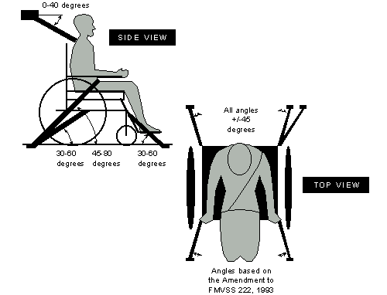
Section 11: Accessibility Features
- Call-A-Bus uses a 4-point securement system for wheelchairs and scooters.
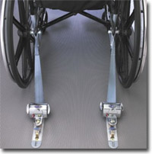
- Buses are equipped with lifts to assist customers with exiting and/or entering the vehicle.
- Buses are equipped with handrails to aid customers in entering and/or exiting the vehicle.
- Drivers may offer verbal assistance or a simple guiding of the hands.
- Drivers can assist in placing your walker or cane into the vehicle.
It is the driver's responsibility to ensure all mobility devices are properly secured while in the vehicle, whether occupied or not. For your safety, please follow the instructions of your driver. Mobility devices cannot move more than two inches while on the lift platform or in the securement area. Drivers are instructed not to transport devices that can move more than two inches.
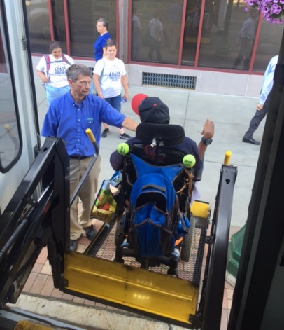
WHEELCHAIRS:
Centro Call-A-Bus vehicles are equipped with a lift to accommodate wheelchairs. Some oversized wheelchairs may exceed the lift capacity and cannot be accommodated. If you have concerns about your wheelchair’s size or weight fitting on our vehicles, please contact your local Call-A-Bus office and we will make arrangements to have a supervisor inspect your wheelchair.
Customers must wait for the driver's instruction for boarding the lifts and positioning the wheelchair for proper securement in the vehicle. Please apply your brakes and turn off controls while riding on the lift and while the wheelchair is in the securement position.
SCOOTERS:
Scooters are electrically-powered devices with a central post supporting the seat. Some scooter manufacturers provide a written disclaimer to the owner that the device should not be used as a seat on a moving vehicle. You may ride your scooter on the lift. Please apply your brakes and turn off controls while riding on the lift and also while the scooter is in the securement position. Centro Call-A-Bus strongly recommends you transfer to a fixed seat, but it is your choice. If you remain in the scooter while being transported, the driver will secure your scooter and assist you in securing your seat belt.

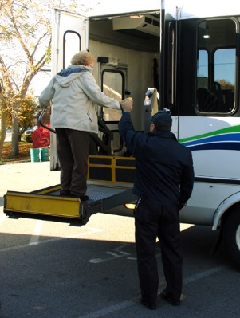
WALKERS, CANES AND CRUTCHES:
Vehicles are equipped with handrails to aid in entering/exiting vehicles. Drivers will offer verbal assistance or a simple guiding of hands and will place your walker or cane in the vehicle.
Customers who are unable to use the steps to enter the vehicle may stand on the passenger lift to board and exit the vehicle. If you choose to stand on the lift, you must be able to stand without assistance and hold onto the rails with both hands.
BREATHING DEVICES:
Breathing aids such as portable respirators or portable oxygen are welcome. You or your PCA are responsible for handling and monitoring the controls of such devices. Drivers are not trained in handling these devices. Customers are responsible for having an adequate oxygen supply for their trip and any reasonable travel delays that might occur. Please plan ahead.
OTHER DEVICES:
Advancing technology has resulted in new and improved mobility devices continuously being developed. If you travel with a device or aid not listed here, please contact us. Call-A-Bus will work with you to make your travel both pleasant and safe.
Section 12: Passenger Responsibilities
Please remember to:
- Answer the questions completely and accurately on your Call-A-Bus application and provide us with an accurate description of your ability to use the Centro Fixed Route Bus and Call-A-Bus.
- Notify us of any change in your functional mobility that might impact using the Centro Fixed Route Bus and Call-A-Bus. You may be asked to submit another application to recertify for Call-A-Bus.
- Reserve trips you need at least a day in advance. Please let us know at request time of any special conditions or needs you may have.
- Cancel as soon as possible, in the event you cannot travel.
- Respect the rights and comfort of other passengers. We ask that you maintain an acceptable standard of personal hygiene, refrain from eating and drinking on board, place trash in receptacles, and use radios or personal listening devices with earphones only.
- Customers are limited to 6 regular-sized bags per paying customer. All bags/items must fit within your personal seating space on the vehicle. No oversized or bulky items are permitted aboard Call-A-Bus vehicles. Carts must be unloaded, folded, and safely secured for transport.
- Refrain from using profanity, obscene language, derogatory statements, abuse, or threatening conduct. This type of language or behavior may result in your removal from the vehicle and/or suspension from Call-A-Bus service.
- Check to ensure that you have all of your belongings before exiting the vehicle.
- Be prepared and ready prior to your scheduled pick-up time.
- Call the dispatcher to check on your ride if your driver has not arrived yet and it is 10 minutes past your confirmed pick up time.
- Follow the guidance and directions of your driver to ensure a safe and comfortable ride. Please do not distract drivers while the vehicle is moving.
- Maintain your mobility devices in a safe condition according to the manufacturer's specification (e.g., free from structural tears in material, no inoperable brakes, no cracked frames/wheels etc.).
Section 13: Call-A-Bus Responsibilities to Our Passengers
We have a responsibility to:
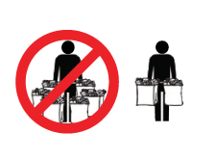
- Collect accurate information from you in order to enter a trip request that meets your needs to the best of our abilities.
LIMIT: 6 Shopping Bags
- Accommodate requests for reasonable service modifications as long as the request does not fundamentally alter service or create a direct threat to the health or safety of others.
- Provide timely service throughout your Call-A-Bus experience.
- Provide clean, safe, well-maintained vehicles for you to travel in.
- Provide a courteous, well-trained, and safe driver.
- Provide driver assistance in boarding and exiting the vehicle. The driver will also provide an escort to the outer door or carry packages, if requested in advance. There is a 6 shopping bag limit per paying customer.
PLEASE NOTE: Drivers are not required to perform tasks that could be provided by a Personal Care Attendant.

Section 14: Respect the Ride
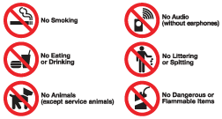
For the comfort and safety of all on board, we ask that you abide by these common rules:
- Any activity that is considered in violation of New York State or Federal Law (e.g., assault, theft) will not be permitted. Call-A-Bus reserves the right to suspend service for any customer in violation of this rule.
- Do not distract the driver with excessive communication.
- Eating, drinking, or smoking on board is not allowed. If you must eat or drink due to a medical condition, please alert the driver.
- Do not litter on the bus.
- Soliciting and selling merchandise or services is not permitted on board.
- Radios and other music or listening equipment may not be played aloud while in transit. Personal listening devices with headphones or ear devices are allowed.
- Call-A-Bus reserves the right to refuse service to anyone who is clearly intoxicated, under the influence of illegal drugs, or whose irrational behavior would be considered a risk to the driver or other passengers.
- Call-A-Bus may refuse service to anyone who clearly presents a biological hazard to others in the vehicle. This includes people whose body or clothing is soiled with blood, vomit, urine, or feces.
- Please remember that Call-A-Bus is a ride sharing service, and each passenger is expected to adhere to these basic rules to ensure an enjoyable transit experience for all.
- Please be sure to check for and take all personal belongings when exiting the vehicle.
PLEASE NOTE: Items found on buses are turned in to Lost and Found. If you lose something, please call (315) 442-3400 or email us at cnyrta@centro.org. If you happen to find an item while riding Call-A-Bus, please give it to the bus operator who will turn it in to Lost and Found.
Items may be picked up Monday through Friday from 8:00 AM until 5:00 PM at Centro’s office. Unclaimed items will be disposed of after 15 days.
For health & safety reasons, Call-A-Bus does not retain any food or clothing items.

Section 15: Cancellations and Changes

To change a trip reservation, you must call by 5:00 PM the day before your scheduled trip or cancel your ride through the MOVE app. Our cancellation lines are open 24 hours a day, 7 days a week.
We realize that a "day in advance" cancellation notice is not always possible. Please call us or cancel on the MOVE app as soon as possible, or at least 2 hours before your scheduled pick-up time. Be sure to let us know if you are canceling a single ride or a round trip.
Last-minute cancellations are an inconvenience for other customers who might have been scheduled to ride with you. Please be considerate of others.
Individuals who have a pattern of frequently reserving trips and then canceling them on the same day as travel will be contacted by Call-A-Bus management. If the customer continues to abuse the trip reservation system, they may have their service temporarily suspended. If a customer cancels on the same day of travel more than 30% of their trips in 30 days, Call-A-Bus may suspend their service for 7 days. A letter of suspension will be sent by mail and will be in effect starting 15 days from the date of the letter.
Only Call-A-Bus Transportation Coordinators and Centro Dispatchers can cancel or change a trip reservation. Drivers are not allowed to accept new trip reservations, make changes to their itinerary, or cancel a trip.
Section 16: No-Shows and Late-Shows
One of the worst inconveniences for Call-A-Bus customers is waiting for other customers who never board the vehicle when it arrives to pick them up. Call-A-Bus drivers are obligated to wait 5 minutes beyond the scheduled pick-up time for a customer to board the vehicle. If no one appears, it will be considered a No-Show. The driver notifies Call-A-Bus that their customer has not boarded, confirms the time, and leaves the site to pick-up or drop-off the next customer.
Customers that board the vehicle more than 5 minutes beyond their scheduled pick-up time are reported as a No-Show/Late-Show.
If the customer cancels the trip when the vehicle arrives it is called a Cancels-at-the-Door. Again, the driver notifies Call-A-Bus that the customer has not boarded the vehicle, confirms the time, and leaves the site for the next customer.
No-Shows, Late-Shows, or Cancels-at-the-Door are posted to the customer's file. If a Call-A-Bus customer has No-Show, Late-Show, or Cancels-at-the-Door filings totaling 30% of their last 20 trips (6 violations), they will be contacted by Call-A-Bus and issued a warning letter. If a Call-A-Bus customer has No-Show, Late-Show, or Cancels-at-the-Door filings totaling 30% of their last 50 trips (15 violations), they may be suspended for up to 7 consecutive calendar days. This suspension will be communicated in writing, by mail. You will have 10 days from the postmark date of written notification to appeal. Please refer to Section 17 of the Call-A-Bus Riders Guide for instructions on filing your appeal.
Please be considerate of other Call-A-Bus customers by reserving your trips carefully, confirming your ride times, and canceling unwanted trips in a timely manner. By doing so, you ensure that everyone receives excellent service.
PLEASE NOTE: Only No-Shows, Late-Shows, or Cancels-at-the-Door that are under the rider’s control will be counted against the rider. No-Shows, Late-Shows, or Cancels-at-the-Door caused by reasons beyond the rider’s control (e.g., scheduling problems, late pick-ups, operational problems on the part of the transit provider, family emergencies, or extreme medical conditions), or due to operator error will not be counted against the rider.
Section 17: Comments, Compliments, and Complaints
Any time you use the Centro system for your transportation needs, we hope you will have a satisfying experience. However, we realize there are times when you may have questions or concerns about the service you received. We encourage customers to provide us with feedback when your service is less than you expected or better than expected. We use this valuable information when we consider future changes or enhancements to our system. We offer you three ways to contact us:


By Phone: Call your local Centro Customer Service Office and a Customer Service Representative will enter your information into a database for review.
By E-mail: Send your comments to cnyrta@centro.org for logging and review.
By Mail: Send your letter to: Centro, PO Box 820, Syracuse, NY 13205
By MOVE: Send your comments through the messaging option in the MOVE app.
All customer comments are forwarded to the Customer Service Supervisor, logged into our centralized complaint management system, assigned a tracking number, and forwarded to the appropriate department for review and/or investigation. The Customer Service Supervisor will send you a postcard once the comment has been officially entered into the system. Should Centro need to contact you, please be sure you provide us with your name and address.
SPECIAL NOTE: We recognize that some people prefer to remain anonymous. There are several well-respected advocacy groups within Centro’s service area that you may wish to contact instead. They will act on your behalf if you request it and we will send our correspondence to them instead of you.

Section 18: Persons with Disabilities Who are Visiting Our Community
Visitors to the Centro service area who have ADA paratransit eligibility on another public transit system are urged to contact Call-A-Bus to arrange for service while in our area. We honor the eligibility certifications of other transit systems, and you may request rides for up to 21 calendar days (per year) without filing a Call-A-Bus application. If you will be visiting for more than 21 days, we request that you complete a Call-A-Bus application so that a local eligibility determination can be made.
Visitors to the Centro service area who either do not have ADA paratransit services available to them or have not previously applied for service in their home area are urged to contact Call-A-Bus to arrange for service while visiting Centro’s service area. In order to qualify as a visitor, applicants will be required to provide proof of residence to Call-A-Bus. Qualified applicants will be eligible to request rides for up to 21 calendar days (per year) without applying for Call-A-Bus services.
Section 19: Appeal Policy and Procedure
Call-A-Bus customers and applicants have the right to appeal any decision made by Centro regarding their eligibility determinations. An appeal is a formal request for reconsideration of the facts relating to your transportation. Customers and applicants may wish to contact Call-A-Bus to discuss any issues or problems first to see if a mutually agreed upon solution can be found prior to requesting an appeal.
Individuals wishing to appeal an eligibility determination/suspension must submit their request in writing. The request must be submitted within 60 days of the initial decision. Appeals should be sent to:
ATTN: Vice President of Operations
Centro
P.O. Box 820, Syracuse, NY 13205


Section 20: Glossary of Terms
ADA PARATRANSIT ELIGIBILITY:
Unconditional Eligibility – Due to functional ability, the customer cannot use the Centro Fixed Route bus or can never get to a bus stop. The customer will be eligible for all trip requests that fall within the times and areas in which Call-A-Bus service operates.
Conditional Eligibility – Customer has the functional ability to use the Centro Fixed Route bus system for some, but not all trips. Call-A-Bus service can be requested when there are situations making a Centro Fixed Route bus trip impossible (e.g., snow and ice are covering walkways, making it impossible to get to a Centro Fixed Route bus stop, or customer must walk farther than able). Call-A-Bus staff will take into consideration all situations prior to determining customer eligibility. Eligibility will be handled on a trip-by-trip basis when the customer calls to request a trip.
All trip requests that meet the eligibility criteria, and fall within the times and areas in which Call-A-Bus service operates, will be honored. If a customer is not eligible for a particular Call-A-Bus trip, the Centro Fixed Route Bus is available as an alternative.
Temporary Eligibility – A short-term disability is present that prevents a customer from using the Centro Fixed Route bus or from getting to and from a bus stop. This eligibility may be conditional or unconditional.
Not Eligible – Based on the information provided on the customer’s application, a functional disability is not stated that would prevent him/her from using the regular Centro Fixed Route bus. Customer is not eligible for the Call-A-Bus program.
Cancels-at-the-Door – This is a No-Show. The customer informs the driver that they will not be taking the ride.
Cancellation – The customer calls to say they will not be taking their requested trip.
Commuter Service – Regular Centro bus service that only operates a few times during the day, typically in the AM and PM when riders are going to and from work.
Companion – Someone who travels with the customer (non-PCA) that must pay a fare. The companion must have the same origin and destination as the customer.
Curb to Curb Service – The driver will assist customer on and off the vehicle.
Door to Door Service – Driver will assist customer from the outer door of pickup location to outer door of drop off location. The customer must signal the driver.
Feeder Service – A combination of Call-A-Bus and the Centro Fixed Route will be used for the customer’s transportation.
Centro Fixed Route Service – This is the regular Centro bus service, operating at fixed times and at fixed stops.

Late Show – Boarding the vehicle 5 minutes past the scheduled pick-up time. A late show is marked as a No-Show even when the customer is transported.
Origin to Destination – Transportation from outer door of initial pickup location to outer door of drop off location.
Paratransit Transportation – Origin to destination transportation, as required by the Americans with Disabilities Act, for individuals with a functional disability to ensure their rights to public transportation.
Personal Care Attendant (PCA) – An individual designated or employed specifically to help the customer meet his/her personal needs. The PCA must have the same origin and destination as the customer. A PCA does not pay a fare to ride with Call-A-Bus.
Ride Share Program – Other customers will be picked up and dropped off during your trip.

Service Animal – Animal that is individually trained to do work or perform tasks for people with disabilities.
¾ Mile Paratransit Corridor – The service area for Call-A-Bus, which matches the Centro Fixed Routes (non-commuter service).
Travel Training – The Travel Trainer teaches participants how to safely and independently use Centro’s system.

Section 21: Important Phone Numbers


Onondaga County - Syracuse
Ride Requests & Confirmations 315-442-3420
Information, Cancellations, & After Hours 315-442-3434

Oneida County - Utica
Ride Requests & Confirmations 315-797-1703

Information, Cancellations, & After Hours 315-797-1703

Oneida County - Rome
Ride Requests & Confirmations 315-797-1703
Information, Cancellations, & After Hours 315-797-1703


Oswego County - Oswego/Fulton/Mexico
Ride Requests & Confirmations 315-342-4400
Information, Cancellations, & After Hours 315-342-4400

Cayuga County - Auburn
Ride Requests & Confirmations 315-253-5765
Information, Cancellations, & After Hours 315-253-5765


Cortland County - Cortland
Ride Requests & Confirmations 315-442-3420
Information, Cancellations, & After Hours 315-442-3434

