
Call-A-Bus
Application
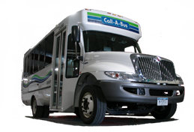

WHAT IS CALL-A-BUS?

Call-A-Bus is a transportation service of the Central New York Regional Transportation Authority (CNYRTA) for persons with a functional disability who are unable to use the Centro fixed route bus for some or all of their trips due to the effects of their disability. Call-A-Bus operates at the same times and in the same areas as the Centro Fixed Route bus with very few exceptions. Call-A-Bus operates in full compliance with the Americans with Disabilities Act (ADA). Individuals are eligible as follows:

- Any person who is unable to board, ride, or exit a Centro Fixed Route bus without the assistance of another person as a result of a physical, visual, or mental disability.


- Any person with a functional disability who has a specific impairment related condition that makes it impossible for them to travel to a Centro Fixed Route bus stop.

CALL-A-BUS SERVICE:

- is NOT human services sponsored transportation or for special event group trips. It is not designed to meet the needs of every disabled person; some people may require more service or assistance than Call-A-Bus can provide.

- is NOT Onondaga Senior Call A Ride (OSCAR/ senior transportation). This program has a different application with different eligibility criteria.
- is NOT for individuals who can use the Centro Fixed Route bus but do not want to.

- is NOT door through door service. Drivers do not escort passengers inside buildings. They will escort passengers to and from an outer door, when requested in advance.

- is NOT responsible for custodial care of our passengers.

- does NOT provide mobility aids for passengers.

WHAT IS THE CENTRO FIXED ROUTE BUS?
- Centro Fixed Route buses operate along fixed routes on an established schedule.

- They are accessible with lifts, ramps, and low floors.

- They have the ability to kneel, and have preferential seating for people with disabilities and for seniors.

- They have stop announcements made by the operator.

- They have places to secure wheelchairs or scooters.

- Reduced fares are available for seniors and people with disabilities. Centro fixed route service operates in full compliance with the Americans with Disabilities Act. (ADA)

CALL-A-BUS ELIGIBILITY CATEGORIES

Depending on your functional abilities, there are different eligibility categories. These different types of eligibility are as follows:

- Conditional Eligibility
You have the functional ability to use the Centro Fixed Route bus system for some, but not all of your trips. You can request Call-A-Bus service when there are situations making a Centro Fixed Route bus trip impossible. For example, snow and ice are covering walkways, making it impossible for you to get to a Centro Fixed Route bus stop, or you must walk farther than you are able. Call-A-Bus staff will consider the conditions in which you are eligible on a trip-by-trip basis when you call to request a trip.
Trip requests made that meet your eligibility criteria and fall within the times and areas in which Call-A-Bus service operates will be honored. If you are not eligible for a particular Call-A-Bus trip, the Centro Fixed Route Bus is available as an alternative.

- ELIGIBILITY IN ALL CASES
Due to your functional ability, you cannot use the Centro Fixed Route bus or you can never get to a bus stop. You will be eligible for all trip requests made that fall within the times and areas in which Call-A-Bus service operates.

- Temporary Eligibility (conditional or in all cases)
You may have a short term disability that prevents you from using the Centro Fixed Route bus or getting to and from a bus stop.

COMPLETING THE CALL-A-BUS APPLICATION
There are 2 parts to this application:

PART 1 - APPLICANT INFORMATION
- Requests information about the applicant, including any special needs or limitations which the individual may have.
- Must be filled out completely, either by the applicant or by someone who is assisting the applicant.
- Contains a HIPAA Authorization on page 12. This must be completed by the applicant or by the applicant’s Power of Attorney.

PART 2 - HEALTHCARE PROFESSIONAL
VERIFICATION OF FUNCTIONAL
DISABILITY
- Must be filled out completely, and by only one individual.
- Please read page 13 to determine who may complete Part 2.
- The individual who completes Part 2 must also sign where indicated on page 19.
---------------------------------------
NOTE: For your convenience, following Part 2 there is a checklist which you can use to be sure that you have filled out this application completely.
Following the checklist, there is information regarding the re-certification process, plus the appeals process in the event that you do not agree with the determination of your eligibility status.

PART 1:
APPLICANT INFORMATION:

Please print clearly.

1. Today’s Date: _____________________________________

2. Purpose of this Application:
- I am applying as a new Call-A-Bus customer.

- I am an active CALL-A-BUS customer, my abilities have changed,
and I would like to update my records. ID# __________________.

- My eligibility is expiring. I am recertifying to continue to receive
CALL-A-BUS Services. ID# ________________________.
3. Applicant’s First Name: ______________________________________________

4. Last Name: _________________________________________________________
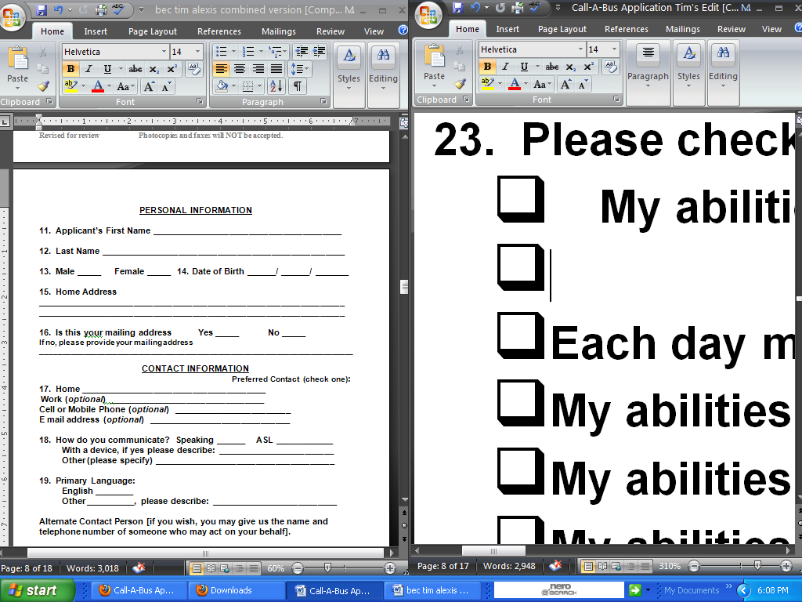
5. Male Female 14. Date of Birth: ________/ _______/ _______

6. Home Address:
______________________________________________________________________

______________________________________________________________________
7. Is this your mailing address: Yes No (If no, please provide your
mailing address below): ______________________________________________________________________

______________________________________________________________________

CONTACT INFORMATION

Preferred Contact Number (check one):
8. Home: ______________________________________________
Work : _____________________________________________
Cell or Mobile Phone: _________________________________

E mail address (optional): _____________________________________________

9. How do you communicate?
Speaking ASL Other (please describe): _____________________

10. Primary Language:
English Other: (please describe)_______________________________

Alternate Contact Person [if you wish, you may give us the name and telephone number of someone who may act on your behalf]:
Name:_________________________________________________________________
Relationship to Applicant:________________________________________________

Telephone Number(s): ___________________________________________________

Applicant’s Travel Abilities and History

11. Please indicate any situation where you use the Centro Fixed Route or Call-A-
Bus service:

Address I travel by
______________________________________________________________________

______________________________________________________________________

______________________________________________________________________

______________________________________________________________________

______________________________________________________________________

12. I can travel, but I need the help of a guide or aide: Yes No
[If yes, you must provide your own aide, guide, or escort.]

13. Please check any statement that describes your abilities.
- My abilities do not change much from day to day
- Each day my abilities change without warning
- My abilities are improving with time
- My abilities are getting worse with time
- My abilities seem to change with a change in the
weather or time of day

14. I can travel on my own (walking, using my wheelchair or scooter,
using my cane or walker): Check One Only
- I cannot travel on my own at all
- I can travel to the curb
- I can go One (1) block
- I can go Three (3) blocks (1/4 mile)
- I can go Six (6) blocks (1/2 mile)
- I can go Nine (9) blocks (3/4 mile)
- My power wheelchair or scooter gives me the
mobility to travel long distances.
- Other, specify distance______________________

15. I can get to the bus stop near my home:
Yes No I do not know where it is

16. Where is the bus stop? Please name the street and the “cross”
street: _______________________________________________________________

Please check a response for each of the following statements:
17. I use Centro Fixed Route Buses: Yes No Some Trips
18. I want to learn to use the Centro Yes No Some Trips
Fixed Route Bus:
19. I can get to the Centro Fixed Route Yes No Some Trips
Bus Stop:
20. I can ask for and follow directions: Yes No Sometimes

21. I can wait outside at the bus stop
without a bench or something to lean Yes No Some Trips
on:
22. I can wait outside in cold weather for 10 minutes: Yes No
23. I can wait outside in hot weather for 10 minutes: Yes No
24. I can get on and off a bus without assistance: Yes No
25. I can put my money or pass in the fare box: Yes No

26. I can recognize where to get off the
bus: Yes No Some Trips
27. I can transfer from one bus to another: Yes No

28. I can get from the bus to places I want
to go: Yes No Some Trips

29. Please check all that apply that would prevent you from getting to and from your origin and destination. For each box checked, please provide a detailed explanation of how travel is affected.
- If there are no curb cuts:____________________________________________

_________________________________________________________________

_________________________________________________________________

- If surface is uneven:________________________________________________

_________________________________________________________________

_________________________________________________________________

- If sidewalk or terrain is too steep:____________________________________

_________________________________________________________________

_________________________________________________________________

- If there is snow or ice:______________________________________________

_________________________________________________________________

_________________________________________________________________

30. Please tell us, in your own words, what is preventing you from using the
Centro Fixed Route Bus system:
______________________________________________________________________

______________________________________________________________________

______________________________________________________________________

______________________________________________________________________

______________________________________________________________________

______________________________________________________________________

______________________________________________________________________

______________________________________________________________________

______________________________________________________________________

______________________________________________________________________

______________________________________________________________________

______________________________________________________________________

______________________________________________________________________

______________________________________________________________________

31. I use the following aids or devices when I travel: (Call-A-Bus does not provide
mobility aids for passengers). Check all that apply.
NONE
Manual wheelchair
Power wheelchair
Power scooter
Walker
Cane
White Cane
Crutches
Service Animal (A service animal is a specially trained animal that provides assistance to the person. Family pets are not service animals.)
Hearing Aid
Portable Oxygen or Breathing device
Personal Care Attendant, Sighted Guide, or Escort

If someone other than the Applicant completed this form, please provide the following:

32. Your Name:_________________________________________________________

33. Phone:___________________ 34. E mail address:_________________________

35. Address: ______________________________________________________________________

______________________________________________________________________

36. Relationship to Applicant _____________________________________________

37. How did you assist in completing this form:
- I formulated the answers based on my own knowledge of the individual.
- I read the questions to the applicant and wrote the answer they provided.
- Other: (please describe)_____________________________________________

38. Signature:__________________________________________________________

39. Date:______________________________________________________________

HIPAA Authorization
(To be completed by applicant
or applicant’s power of attorney)

I, the undersigned Applicant, understand that the purpose of this Application is to determine my eligibility to use CALL-A-BUS.

I hereby certify that all information provided by me on this application is, to the best of my knowledge, true and accurate. I understand that the willful falsification of any information I have provided, could result in a cancellation of any CALL-A-BUS service that I may have previously been qualified to receive.

HIPAA Authorization
I, or my authorized representative, request that health information be released by my verifier in order to complete the attached form, in accordance with New York State law and the Privacy Rule of the Health Insurance Portability and Accountability Act of 1996 (HIPAA). I understand that I have the right to revoke this authorization at any time by writing to the verifier except to the extent that action has already been taken based on this authorization. I understand that signing this authorization is voluntary. Information disclosed under this authorization might be re-disclosed by the recipient and this re-disclosure may no longer be protected by federal or state law. This authorization will expire one year from the date below.

______________________________________________________________________
APPLICANT’S SIGNATURE DATE

OR, if applicant is unable to sign:

POWER OF ATTORNEY’S SIGNATURE DATE
(By signing here, you are verifying that you have legal power of attorney for the applicant stated in this application.)

Please have your HEALTH CARE PROFESSIONAL VERIFIER complete Part 2.

END OF PART 1

Part 2:
Healthcare Professional Verification
Of Functional Disability

- Must be filled out completely, and by only one individual.
- Please read this page to determine who may complete Part 2.
- The individual who completes Part 2 must also sign where indicated on page 19.

Who can complete part 2 of this application?
The verifier completing this portion of the application (pages 15 through 20) should be a person who is one of the following:
- Masters level social worker
- Registered Nurse (RN)
- Licensed Practical Nurse (LPN)
- Certified Orientation and Mobility Specialist
- Physical or Occupational Therapist
- Certified Medical Assistant

- Degreed Medicaid Service Coordinator or Case Manager
- Certified Rehabilitation Counselor
- Nurse Practitioner (NP)
- Physician Assistant
- Psychologist
- Physician

*Other verifiers may be appropriate. Please contact the Call-A-Bus office with any questions regarding who is qualified to complete Part 2 of the application.

All questions must be answered on this portion of the application.

IMPORTANT:
- The individual who completes Part 2 must review Part 1 for accuracy before completing Part 2 of this application.
- The individual who completes Part 2 should be someone who is familiar with your functional abilities.
- The same individual who completes Part 2 must be the one who signs Part 2. For example, a Physician’s Assistant cannot answer the questions on Part 2 and then have the doctor sign the application.
- Only one individual should complete and sign the entire Part 2 section.

We may contact your verifier to clarify information they have provided. All information is kept confidential. Also, if a determination cannot be reached based on your application, you may be asked to come in for an in person interview and assessment. We will coordinate this visit to make it convenient for you and we will provide the transportation and assessment at no charge to you.

Call-A-Bus Application for: __________________________________________

Eligibility for CALL-A-BUS is strictly limited to individuals whose disability prevents them from using a Centro Fixed Route Bus or getting to and from a Centro Bus Stop. The individual named above has requested the use of CALL-A-BUS services under the Americans with Disabilities Act of 1990.

Eligibility for CALL-A-BUS is determined by functional ability. Therefore, we ask that you describe what the applicant can and cannot do.

PLEASE NOTE THAT CENTRO FIXED ROUTE BUSES AND MANY BUS STOPS ARE ACCESSIBLE TO MANY PEOPLE WITH DISABILITIES. Buses have ramps or lifts, will “kneel” for those who have difficulties with stairs, have special seating available near the front of the bus and drivers make stop announcements to help with orientation

Centro Fixed Route buses and CALL-A-BUS vehicles can accommodate wheelchairs.

Centro Fixed Route buses and CALL-A-BUS vehicles have ramps and lifts. Some oversized wheelchairs exceed the weight limit and we cannot accommodate them.

CALL-A-BUS service is not medical transportation with door through door service. Our drivers will escort a person from the front door to the vehicle, but cannot go into a building to escort a passenger from an interior office.

CALL-A-BUS does not provide monitors on its vehicles. A passenger must be able to travel alone or have a personal care attendant, escort, or sighted guide provided by the passenger.

HIPAA authorization is on page 12.

PLEASE PRINT CLEARLY
The following pages (pages 15-19) must be filled out and signed by only ONE person.
V1. I, _________________________________________________ have reviewed Part 1 of this
application.

V2. Applicant’s diagnoses: ____________________________________________________________
__________________________________________________________________________________

V3. If the applicant is taking medication that impacts behavior, balance, memory or other activities of
daily living, please describe the effect on their ability to travel independently:________________

__________________________________________________________________________________
V4. Does the applicant have a vision disability: Yes No

(If yes, please complete V4a-V4d. If no, continue to question V5.)

V4a. Please list applicant’s eye condition(s)/ diagnosis: (Please note that writing “legally
blind” is not sufficient):_____________________________________________________

V4b.What is the applicant’s acuity with correction: ___________________________________

V4c. Please list visual field loss (if applicable): ______________________________________

V4d. Please describe how this disability would affect the applicant’s ability to travel:

____________________________________________________________________________

____________________________________________________________________________

____________________________________________________________________________

V5. Does the applicant have a hearing disability: Yes No

(If yes, please complete V5a-V5b. If no, continue to question V6.)

V5a. Please list applicant’s hearing condition/ diagnosis: ______________________________

V5b. Please describe how this disability would affect the applicant’s ability to travel: ________

____________________________________________________________________________

V6. Does the applicant have difficulty with speech/ communication: Yes No
(If yes, please answer V6a. If no, continue to V7.)

V6a. Describe how the applicant’s speech or communication is affected including any
devices or alternative communication methods used: __________________________________

____________________________________________________________________________

____________________________________________________________________________

____________________________________________________________________________

V7. Is the applicant’s disability affected by exposure to heat, cold, humidity or
pollutants: Yes No
(If yes, please answer V7a. If no, continue to V8.)

V7a. Which of the above affects the applicant and what effect does it have on the ability to travel: ____________________________________________________________________________

____________________________________________________________________________

____________________________________________________________________________
V8. Is the applicant able to stand for up to 10 minutes without a bench or Yes No
something to lean on:
(If no, please answer V8a. If yes, continue to V9.)

V8a. Explain how the applicant is prevented from standing for up to 10 minutes:
____________________________________________________________________________

____________________________________________________________________________

____________________________________________________________________________
V9. Is the applicant able to cross streets with pedestrian/traffic signals/control: Yes No
V9a. Is the applicant able to cross streets without pedestrian/traffic Yes No
signals/controls:

(If no to V9 or V9a please answer V9b. If yes, continue to V10.)

V9b. What specifically prevents the applicant from crossing streets: _____________________

____________________________________________________________________________

____________________________________________________________________________

____________________________________________________________________________
V10. Is the applicant oriented to time and place: Yes No
V11. Can the applicant ask for and follow directions: Yes No
V12. Is the applicant socially appropriate in public: Yes No (If no, please answer V12a. If yes, continue to V13.)

V12a.Please describe how the applicant is not socially appropriate in public:_______________

____________________________________________________________________________

____________________________________________________________________________

____________________________________________________________________________
V13. Is the applicant’s short or long term memory affected: Yes No
(If yes, please answer V13a. If no, continue to V14.)

V13a. Please describe how the applicant’s memory is affected:__________________________

____________________________________________________________________________

____________________________________________________________________________

____________________________________________________________________________
V14. Does the applicant have deficits in his/her ability to problem solve: Yes No (If yes, answer V14a. If no, continue to V15.)

V14a. Describe the applicant’s deficits in problem solving: _____________________________

____________________________________________________________________________

____________________________________________________________________________
V15. Is the applicant able to recognize landmarks or destinations: Yes No

V16. Is there a goal of traveling independently using Centro Fixed Route Buses?
(even if limited to neighborhood or to and from employment) Yes No
V17. Applicant’s condition is: permanent temporary

V17a. If temporary, how long is the condition expected to affect abilities? ________ (months)

V18. Applicant’s condition is: relatively stable changes every day

Other, please specify:__________________________________________________________

____________________________________________________________________________
V18a. Applicant’s condition: changes at different times of day: Yes No

V18b. If yes, what times of day and how is functional ability affected? ____________________________________________________________________________

____________________________________________________________________________

V19. Please place an X in each box that applies for how far applicant can travel INDEPENDENTLY
with and/or without a mobility device:

 | BY WALKING  (without cane, walker, or crutches) | BY WALKING  (with a cane, walker, or crutches) | BY USING A MANUAL WHEELCHAIR  (if applicable)
Cannot travel on their own at all
Can travel to the curb only
Can go One (1) block
Can go Three (3) blocks (1/4 mile)
Can go Six (6) blocks (1/2 mile)
Can go Nine (9) blocks (3/4 mile)
Other, specify distance:

OR (if applicable) CHECK BOX BELOW

Applicant has a power wheelchair or scooter that gives the mobility to travel long distances: Yes

V20. If applicant is not able to travel independently, please explain why: __________________________________________________________________________________

__________________________________________________________________________________

__________________________________________________________________________________

V21. Are there any other effects of this person’s disability or disabilities that will impact the ability to
travel? Please consider their physical, cognitive, and sensory abilities and their mental health
status, if appropriate: __________________________________________________________________________________

__________________________________________________________________________________

__________________________________________________________________________________

If not stamped, PRINT your name and Please stamp your name and address below:
address below:

__________________________________

__________________________________

__________________________________

Office Phone #: _____________________

Office, Agency, or Clinic Name:________________________________________________________

How long have you known the applicant: _________________________________________________

Title/Degree: ________________________Certification or License # (if applicable):_______________

THE PERSON WHO SIGNS BELOW MUST BE THE SAME PERSON WHO COMPLETED PART 2 OF APPLICATION (pages 15-19). CALL-A-BUS WILL
NOT ACCEPT PART 2 IF FILLED OUT BY MORE THAN ONE PERSON.

The verifier signing this form should be a person who is one of the following: Masters level Social Worker, Registered Nurse (RN or LPN or NP), Certified Orientation and Mobility Specialist, Physical or Occupational Therapist, Degreed Medicaid Service Coordinator or Case Manager, Certified Rehabilitation Counselor, Physician Assistant, Psychologist, Physician. Other verifiers may be appropriate. Please contact the Call-A-Bus office with any questions regarding who is qualified. The verifier should be someone who is familiar with the applicant’s abilities.
Signature: ___________________________ Date: __________________
(Signature is required or application will be returned as incomplete.)

END OF PART 2

APPLICATION CHECKLIST

Incomplete applications and/or photocopies/ faxes cannot be processed and are returned to the applicant. Incomplete applications are returned to you with a letter that explains the information that is needed in order for the application to be processed.

Please use the following checklist to ensure your application is complete:
AREA TO CHECK: | PAGE(s) | YES | NO
Part 1 completed, all questions answered. | 5-12
HIPPA Authorization signed by  customer or power of attorney. | 12
Applicant’s name written on Part 2 | 14
Part 2 completed by verifier, all  questions answered, and detailed comments given (where required). | 14-19
The verifier who completed Part 2 is the same person who signed Part 2. | 19
Original application (not photocopy or fax) returned to Call-A-Bus. | 5-19
If you answered NO to any of the above questions, your application may be sent back as incomplete.

When both parts of the application are complete, please mail original to:

Call-A-Bus
PO Box 820
Syracuse, NY 13205-0820

When your eligibility for Call-A-Bus has been determined, we will notify you in writing.

ELIGIBILITY RECERTIFICATION
Call-A-Bus eligibility determinations are good for up to 5 years. The eligibility letter you receive will have the expiration date of service. In order to have continued eligibility, you will have to recertify for service once this date is approached. We understand that your abilities to travel may change. You may submit a new application for Call-A-Bus service at anytime. We may also ask you to complete another application if we have reason to believe your abilities have changed.

Centro staff may need to assess path of travel when making determinations of eligibility.

APPEALS:
WHAT TO DO IF YOU DO NOT AGREE WITH
THE ELIGIBILITY DECISION THAT HAS BEEN MADE

You have the right to appeal your eligibility determination. A copy of the Appeal Procedures will be included with your eligibility letter.

Individuals wishing to appeal must submit their request in writing. The request must be submitted within 60 days of the initial decision. An appeal should be sent to:

Vice-President of Operations
Centro
P.O. Box 820
Syracuse, NY 13205

If you require this application or information in another format such as larger print, Braille, or on tape, please contact your local Centro Customer Service at one of the numbers below:

-Onondaga County (315) 442-3400
-Oswego County (315) 342-4400
-Cayuga County (315) 253-5765
-Oneida County
-Utica (315) 797-7803
-Rome (315) 336-5310

Visit us online @ www.centro.org

