# *Do I qualify for* Call-A-Bus?



**ANSWER:** To qualify for Call-A-Bus service, you must have a disability that prevents you from traveling on Centro transit buses.

### Non-Qualifying Factors:

* Distance to a bus stop
* Age
* Lack of available Centro transit bus service
* Inability to drive a car
* Inconvenience
* Decreased comfort

Your approval for Call-A-Bus service does not guarantee your ability to use the service in all cases. For some, your eligibility may be conditional or temporary.



# *How do I apply* for service?

**Call-A-Bus Information**

## Syracuse

Daily: 8:00am - 5:00pm (315) 442-3434

**Centro’s ADA Paratransit Service**

**Oswego**

Monday - Friday: 8:00am - 5:00pm (315) 342-4400

**Auburn**

Monday - Friday: 8:00am - 5:00pm (315) 253-5765

**Utica & Rome** Daily: 8:00am - 5:00pm (315) 797-1703

**ANSWER:** To apply for service, you must complete a Call-A-Bus application. Part 1 of the application will be completed by you, while Part 2 will be completed by a healthcare professional of your choice. To request an application, contact your local Call-A-Bus offi ce (see back cover for phone numbers) or download a copy from our website:

[***www.centro.org***](http://www.centro.org/)





200 Cortland Avenue

P.O. Box 820

Syracuse, NY 13205-0820

[www.centro.org](http://www.centro.org/) • (315) 442-3400

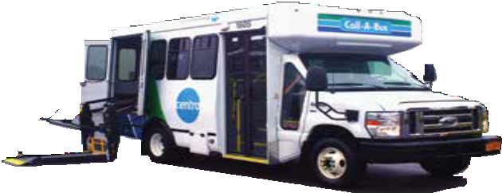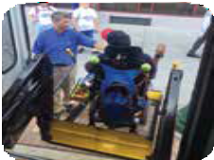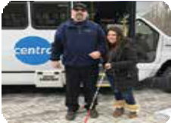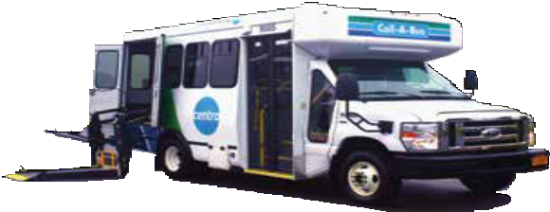

**Centro’s ADA Paratransit Service**



***What is Call-A-Bus?***



***How much does it cost to ride?***

**ANSWER:** Call-A-Bus is a transportation service for people with disabilities who are unable to ride Centro transit buses due to their disability.

**Call-A-Bus is:**

***Coordinated transportation***, meaning you may be riding in a specially marked Call-A-Bus vehicle, or a certified vendor shuttle, vendor

* 1. door sedan, or vendor minivan.

***Ride sharing***, meaning you will be riding in a vehicle, along with other passengers.

***Origin-to-Destination***, meaning the driver will meet you at the curb of your trip origin and transport you to an accessible curb at your trip destination. Upon advanced request, the driver will assist you from the outer door of your origin to the outer door of your destination. For the safety of passengers, the vehicle must remain within sight of the driver at all times.

Drivers will assist customers with boarding and exiting vehicles as well as securing mobility devices. Upon request, drivers will provide assistance with limited packages.

### Call-A-Bus is NOT:

* + - A taxi service
    - Senior transportation
    - Door-through-door service
    - Custodial care
    - A mobility aide provider

**ANSWER:** Call-A-Bus service is available in the same area covered by the regular Centro transit bus routes and extends beyond the area of each regular bus route by a 3/4 mile radius.

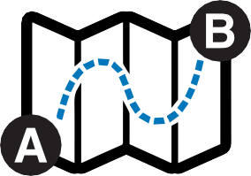

***Where does the Call-A-Bus service travel to?***



Call-A-Bus service is available in Onondaga, Oswego, Cayuga, and Oneida Counties and serves the following cities: Syracuse, Oswego, Fulton, Auburn, Rome and Utica.

**Service Area**

**ANSWER:** Bus fares for Call-A-Bus customers are as follows:

|  |  |
| --- | --- |
| **Syracuse Zone 1:** | **$2.50 \*** |
| **Syracuse Zone 2:** | **$3.00 +** |
| **Oswego:** | **$2.00** |
| **Auburn:** | **$2.00** |
| **Rome:** | **$2.00** |
| **Utica:** | **$2.50** |

**\* Zone 1:** Any trip that is less than 6 miles from origin-to-destination.

**+ Zone 2:** Any trip that is 6 miles or more from origin-to-destination.

Some Call-A-Bus trips may require additional fare. When making your trip request, the Call-A-Bus Transportation Coordinator will provide you with the exact fare amount required for your trip.

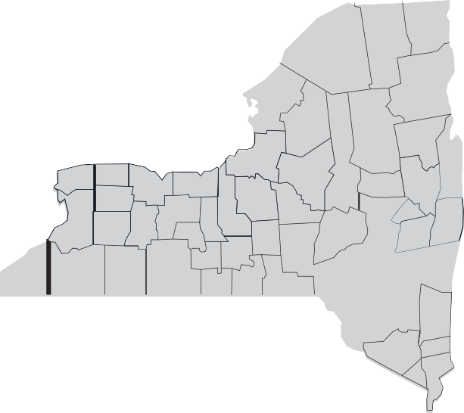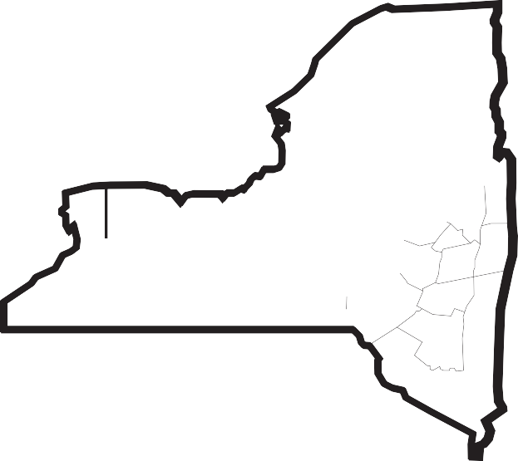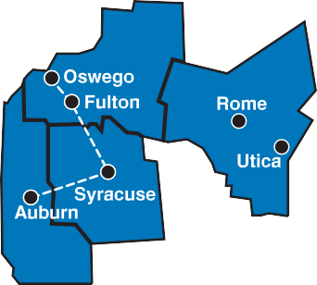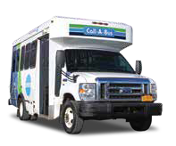

### Call-A-Bus Ride Passes

Call-A-Bus Passes are available at:

* Centro’s Online Store
* Main Offices
* Transit Hubs
* Pass Vending Machines
* Participating Pass vendors listed at

[***www.centro.org***](http://www.centro.org/)