
Amphitheater Event Shuttle Service
Tim McGraw– 7:00 PM Concert

Friday, July 31, 2026

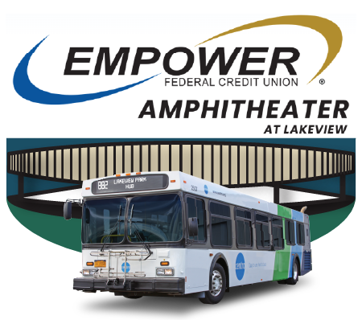
Centro will be providing shuttle service to and from the Empower Federal Credit Union Health Amphitheater at Lakeview from its temporary stop on Warren St. across from the Centro Transit Hub on Friday, July 31, for the Tim McGraw concert.

Shuttle service begins approximately 2 hours before the concert and will end approximately 30 minutes after the show concludes.

Accepted forms of payment include cash, valid Centro ride passes, mobile passes via the GoCentroBus mobile app, or credit/debit cards.

Shuttle information is available on Centro’s website (www.centro.org) and social media channels as well as at the Centro Transit Hub.

REMINDER: The last bus line-up leaves the Transit Hub at 11:40 PM.



